**DAILY ONLINE ACTIVITIES SUMMARY**

|  |  |  |  |  |  |  |  |  |
| --- | --- | --- | --- | --- | --- | --- | --- | --- |
| **Date:** | 16-06-2020 | | | | | **Name:** | D Richard Franklin | |
| **Sem & Sec** | Fourth sem section A | | | | | **USN:** | 4AL18CS020 | |
| **Online Test Summary** | | | | | | | | |
| **Subject** | | Complex analysis, probability and statistical methods | | | | | | |
| **Max. Marks** | | 30 | | **Score** | | | 28 | |
| **Certification Course Summary** | | | | | | | | |
| **Course** | 1. **Mastering big data analytics** | | | | | | | |
| **Certificate Provider** | | | greatlearning | | **Duration** | | | 3 hr |
| **Coding Challenges** | | | | | | | | |
| **Problem Statement:**  1: program to binary reversal of a number. | | | | | | | | |
| **Status:** completed | | | | | | | | |
| **Uploaded the report in Github** | | | | | yes | | | |
| **If yes Repository name** | | | | | <https://github.com/alvas-education-foundation/Richard_Franklin> | | | |
| **Uploaded the report in slack** | | | | | yes | | | |

**Online Test Details:**

The test for today was from module 1. The test was of objective type questions and there were 30 questions and the duration was 45 minutes. The questions were optimal and easy. The score that I got was 28/30.

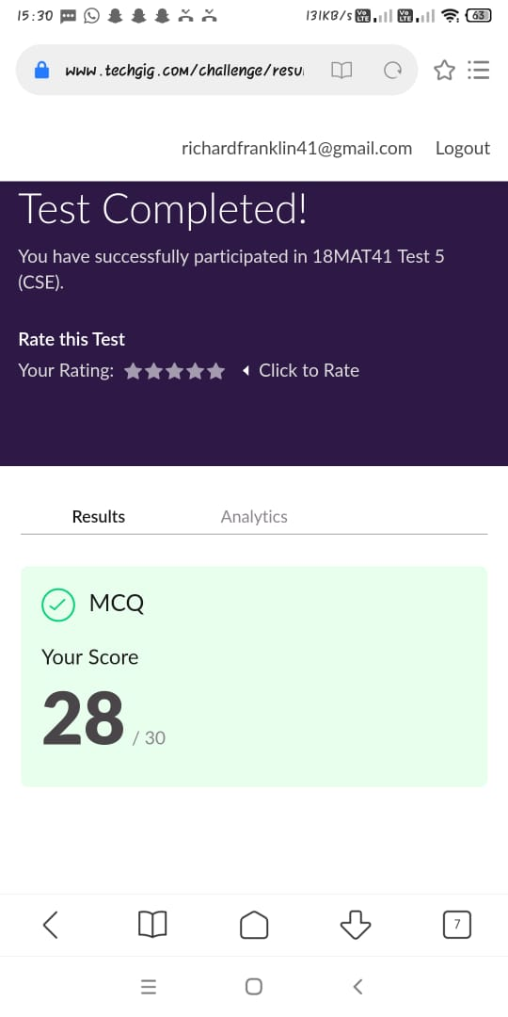

**Online Course Details:**

1. Name of course: **Mastering big data analytics**

Certificate provider: greatlearning

The total course was about how we can get thorough with big data analysis and to master the art. Today I went through the section of the course which was about SPARK. Here I learnt about SPARK basics, its architecture, terminologies and how it’s different compared to Hadoop. Few other stuffs related to it was also told here.

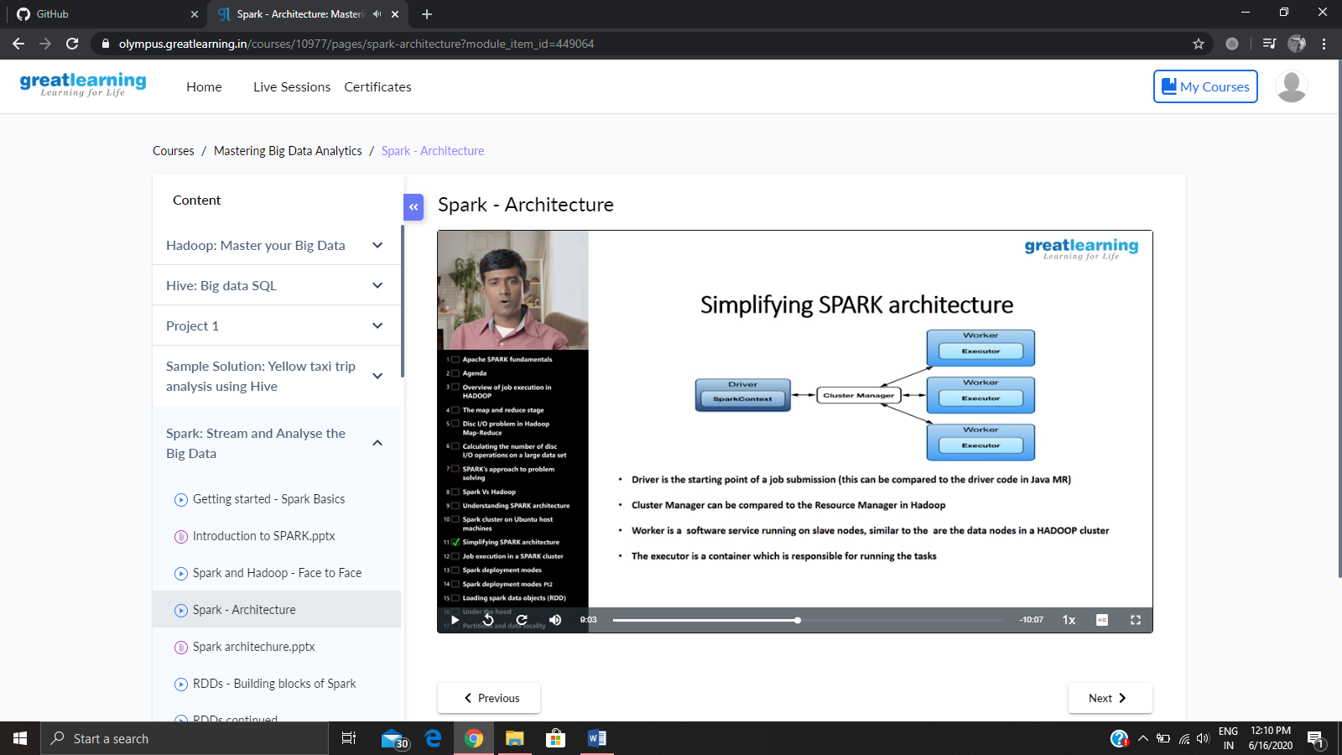

**Online coding:**

Problem 1: (using C language) program to binary reversal of a number.

